

**SOEN 6841**

**Software Project Management**

**FALL 2024**

**Group 3**

**Topic 29: Emergency Response Coordination System**

Github: <https://github.com/Ayushhpatel04/SOEN-6841-SPM>

|  |  |
| --- | --- |
| **Group Members** | **Student Id** |
| Harsh Tank | 40269370 |
| Ayush Patel | 40272388 |
| Zeel Divawala | 40272584 |
| Ankush desai | 40271170 |
| Mihir Gediya | 40272399 |

**Professor: Dr. Joumana Dargham**

# EASIBILITY STUDY

## Introduction

This feasibility study evaluates the technical, operational, and economic viability of the Emergency Response Coordination System (ERCS), a project designed to enhance emergency response coordination. This study provides a thorough analysis of the technological requirements, operational impacts, and economic feasibility, ensuring that the project is practical, sustainable, and valuable for stakeholders. Each component addresses potential risks, benefits, and implementation strategies to support the successful execution of ERCS.

## Technical Feasibility

### Evaluation of the Technology Requirements for the Software Solution

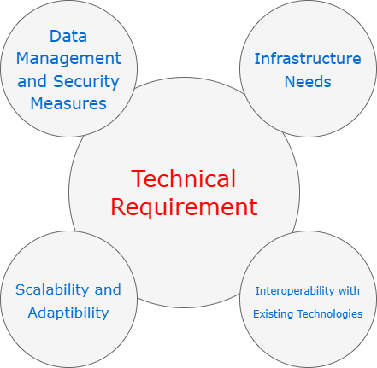

#### Infrastructure Needs:

* ERCS requires a highly scalable and reliable infrastructure to support real-time data processing and communication. Cloud platforms like **AWS** or **Microsoft Azure** are suitable due to their robust scalability, flexibility, and data security features, ensuring that the system can handle variable loads during emergencies.
* **Frontend Technologies**: The user interface will be developed using frameworks like **React** or **Angular**, which offer responsive design and seamless interaction. These frameworks support multi-device compatibility, ensuring accessibility for users on desktops, tablets, and mobile devices.
* **Database Management**: A hybrid database solution will be used, combining **PostgreSQL** for structured data and **MongoDB** for unstructured data. This setup allows efficient data retrieval and flexibility, supporting the system’s diverse data needs, including incident reports, responder availability, and GIS data.

#### Network Infrastructure:

* A reliable network infrastructure is critical for real-time data transmission. **Content Delivery Networks (CDNs)** and **load balancers** will optimize data flow and reduce latency, ensuring consistent communication, even under high loads.

#### API and Third-Party Integrations:

* ERCS will integrate with existing systems through RESTful APIs, allowing interoperability with emergency services, hospitals, and government databases. **Standardized data formats** (e.g., JSON, XML) will facilitate smooth data exchange across platforms.

#### Scalability, Security, and Performance:

* **Scalability**: A **microservices architecture** with containerization (using Docker or Kubernetes) enables independent scaling of system components, allowing ERCS to manage increased loads flexibly.
* **Security**: Data security is paramount due to the sensitive nature of emergency data. ERCS will employ **end-to-end encryption**, **multi-factor authentication (MFA)**, **role-based access control (RBAC)**, and **AI-driven anomaly detection** to safeguard against unauthorized access.
* **Performance**: Real-time data processing and low latency are prioritized to ensure the responsiveness of ERCS during emergencies.

### Assessment of the Feasibility of Implementing the Required Technology

#### Availability of Technology:

* The technology stack (cloud infrastructure, frontend frameworks, databases) is mature and widely available. Open-source components and established platforms (e.g., AWS, Docker) reduce the risk associated with technology availability, while offering flexibility for customization.

#### Technical Expertise:

* Skilled personnel, including developers, data scientists, and security experts, are crucial for ERCS. A hiring strategy will prioritize individuals experienced in cloud infrastructure, API integration, and cybersecurity to ensure successful implementation.

#### Technical Risks and Mitigation Strategies:

* **Integration Challenges**: Integrating ERCS with existing emergency systems may present compatibility issues. This risk is mitigated by using standardized data formats and conducting thorough compatibility testing.
* **Security Risks**: Sensitive data handling increases vulnerability to breaches. ERCS mitigates this through robust security protocols, including encryption, RBAC, and regular security audits.
* **Scalability Challenges**: Handling high demand during large-scale emergencies may strain resources. Using a microservices architecture with containerized components will support scalability without impacting performance.

#### Future Technological Advancements:

* ERCS is designed to adapt to advancements in AI, IoT, and machine learning, which could further enhance features like predictive analytics and automated resource allocation.

### Risk vs Reward Analysis

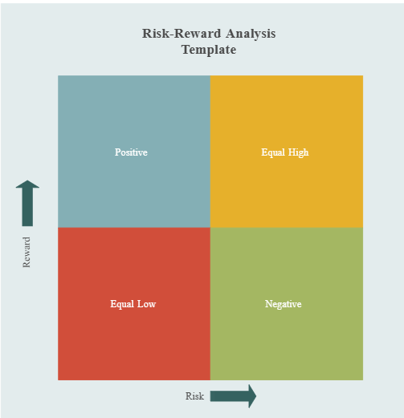

**Quadrant 1: Positive (High Reward, Low Risk)**

These decisions offer substantial rewards with minimal risks, making them safe, highly favorable choices for the ERCS project.

1. **Cloud Infrastructure for Scalability**:

* **Reward**: High scalability, flexibility, and reliability during peak emergency loads.
* **Risk**: Low, as established providers (AWS, Azure) offer secure and reliable services.
* **Rationale**: Cloud infrastructure is essential for scalability, providing high value with low risk.

1. **Frontend Frameworks (React or Angular)**:

* **Reward**: Responsive and user-friendly interfaces accessible across devices, enhancing user experience.
* **Risk**: Low, as these frameworks are mature and widely supported.
* **Rationale**: Offers high usability with minimal risk, supporting a broad user base.

1. **Standardized Data Formats (JSON, XML)**:

* **Reward**: Ensures compatibility and smooth data transfer with external systems.
* **Risk**: Low, as these formats are universally supported.
* **Rationale**: A safe and reliable choice that facilitates data exchange with minimal technical risk.

**Quadrant 2: Equal High (High Reward, High Risk)**

These decisions have significant rewards but also involve higher risks, which require careful management.

1. **Microservices Architecture with Containerization (Docker/Kubernetes)**:

* **Reward**: Independent scalability and fault tolerance for different system components.
* **Risk**: High, due to complex setup and specialized skills required for container orchestration.
* **Rationale**: The modularity and resilience benefits justify the complexity, and additional training mitigates risks.

1. **Advanced Security Measures (Encryption, Multi-Factor Authentication, Anomaly Detection)**:

* **Reward**: Strong data security and regulatory compliance, essential for protecting sensitive information.
* **Risk**: High, with increased setup complexity and costs.
* **Rationale**: Security is critical; these protocols are necessary despite added costs and complexity.

1. **Anomaly Detection with AI for Security Monitoring**:

* **Reward**: Enhances system security by identifying unusual activities in real time.
* **Risk**: High, as AI-driven anomaly detection requires continuous training and monitoring.
* **Rationale**: Real-time monitoring provides significant benefits for data protection, making the complexity worthwhile.

**Quadrant 3: Equal Low (Low Reward, Low Risk)**

These decisions have minimal impact on both reward and risk. While safe, they don’t contribute significantly to the project’s success.

1. **Use of Standardized Data Formats (JSON, XML)**:

* **Reward**: Facilitates interoperability with external systems.
* **Risk**: Low, as it’s a widely used and low-complexity approach.
* **Rationale**: Although it has limited transformative impact, it ensures basic compatibility without risk.

**Quadrant 4: Negative (Low Reward, High Risk)**

This quadrant includes decisions that are generally avoided due to high risks without corresponding rewards. However, none of the technical choices for ERCS falls into this quadrant because unnecessary high-risk, low-reward options (e.g., proprietary data protocols or custom hardware) have been deliberately excluded.

## Operational Feasibility

### Analysis of the Operational Impact of the Proposed Solution on Existing Processes

#### Workflow and Process Changes:

* ERCS will streamline communication across emergency response agencies, reducing manual coordination and enhancing resource allocation efficiency. Agencies will receive real-time data updates, enabling quicker response times.
* **Automated Incident Reporting**: ERCS automates report generation and distribution, reducing administrative workload and providing responders with immediate, accurate information.

#### Role and Responsibility Shifts:

* ERCS introduces data-driven decision-making, changing the roles of some personnel. For instance, dispatchers may take on monitoring responsibilities, using ERCS data to allocate resources dynamically.

**Training Requirements**: Specialized training will be provided to staff to familiarize them with ERCS functionalities and operational workflows.

#### Impact on Productivity, Training, and User Adoption:

* **Productivity**: By automating repetitive tasks, ERCS reduces response times, increases productivity, and minimizes errors in resource deployment.
* **Training Programs**: Initial training will focus on key functions, with ongoing support to address new features or updates. Interactive training sessions will ensure that users are comfortable with the technology.
* **User Adoption**: The system’s ease of use, coupled with its proven operational benefits, will encourage adoption across agencies.

### Identification of Potential Challenges and Benefits in the Operational Context

#### Operational Challenges:

* **User Resistance**: Resistance from personnel accustomed to traditional methods can slow adoption. This will be addressed through regular workshops, demonstrations, and a dedicated support team.
* **Infrastructure Limitations**: Some agencies may lack the necessary infrastructure (e.g., fast internet, modern devices). A phased rollout with infrastructure assessments will help address these gaps.
* **Compliance with Regulations**: ERCS must comply with local, state, and federal data protection regulations. Ongoing consultations with legal and compliance experts will ensure adherence.

#### Operational Benefits:

* **Efficiency Gains**: Real-time data and automated workflows reduce coordination delays, leading to faster, more efficient responses.
* **Cost Savings**: Streamlined resource management minimizes redundant deployments, lowering operational costs over time.
* **Enhanced Safety**: Improved coordination and communication result in better-informed responders, enhancing public safety during emergencies.

## Transition Plan / Change Management Strategy (Challenging Component):

#### Phased Implementation

* **Pilot Testing**: Begin with a small-scale pilot in a controlled environment, involving one department or a specific geographic area. This will allow for initial feedback and early identification of any technical or operational issues.
* **Feedback Integration**: Gather feedback from pilot users, analyze it to identify common challenges, and make necessary adjustments to ERCS before expanding the rollout.
* **Gradual Expansion**: After the pilot phase, implement ERCS in additional departments or regions, scaling up gradually to ensure smooth transitions and minimize disruption.
* **Full Deployment**: Once ERCS has been optimized based on feedback and early rollouts, proceed with organization-wide deployment, ensuring support resources are readily available for all users.

#### Training Programs

* **Role-Specific Training**: Develop tailored training modules for different user roles—dispatchers, field responders, and managers—focusing on their specific functions within ERCS.
* **Hands-On Workshops**: Conduct interactive workshops to allow users to practice using ERCS in a controlled setting, encouraging questions and providing immediate feedback.
* **E-Learning Modules and Resources**: Provide online modules, video tutorials, and downloadable guides so users can learn at their own pace and revisit materials as needed.
* **Refresher Training Sessions**: Schedule periodic refresher sessions to update users on new features, best practices, and any changes to system functionality.

#### User Adoption Strategies

* **Clear Communication**: Communicate the benefits of ERCS clearly to all users, emphasizing improvements in efficiency, coordination, and response times.
* **Incentives and Recognition**: Recognize early adopters and designate “ERCS Champions” who can help their peers adapt to the new system, rewarding proficiency and initiative.
* **User Feedback Mechanism**: Establish regular feedback sessions where users can voice concerns, suggest improvements, and report issues, creating a sense of involvement in the system’s development.
* **Progress Updates and Success Stories**: Share periodic updates on the system’s performance and showcase real-life success stories to reinforce ERCS’s value and encourage further adoption.

#### Operational Support

* **Helpdesk Support**: Set up a dedicated helpdesk with trained staff available to assist users with technical issues, answer questions, and provide guidance on ERCS usage.
* **On-Site Support for Initial Rollout**: During the initial rollout, have support personnel on-site to address immediate challenges, assist with troubleshooting, and provide real-time answers.
* **Ongoing Technical Monitoring**: Monitor ERCS’s performance continuously to proactively identify and address technical issues before they affect users.
* **Maintenance and Updates**: Schedule regular maintenance and update cycles to ensure system stability, security, and the addition of any new features or improvements based on user feedback.

## Long-Term Operational Impact

* **Scalability**: Evaluate the system’s capacity to expand and evolve to meet future demands, including compatibility with new and emerging technologies.
* **Sustainability**: Examine the system’s long-term viability, focusing on maintenance, support, and the possibility of necessary upgrades over time.
* **Performance Measurement**: Define metrics to assess the system’s effectiveness in emergency response, including reductions in response time, enhanced outcomes, and stakeholder satisfaction.
* **Feedback Mechanisms**: Establish regular feedback processes from users and stakeholders to support ongoing improvements to the system.

## Economic Feasibility

### Estimation of the Economic Viability of the Project

#### Project Cost Breakdown:

* **Development and Setup**: Estimated at $1.8 million - $2.4 million, covering personnel, infrastructure, and software licenses.
* **Operational and Maintenance Costs**: Projected at $250,000 - $500,000 per year, including updates, troubleshooting, and support.
* **Training and Capacity Building**: Initial training estimated at $30,000 - $60,000, with ongoing support included in annual maintenance.

#### Future Expenses for Scaling or Upgrades:

* As ERCS grows, additional investments in cloud storage, data security, and feature updates may be required. These expenses have been accounted for in the long-term budget, ensuring sustained functionality.

### Consideration of Resource Availability, ROI, and Cost-Benefit Analysis

#### Resource Availability:

* The required technical and human resources are readily available, with potential to partner with cloud providers or software vendors for additional support.

#### Return on Investment (ROI):

* **Roi Calculation:**



* **Break-Even Point**: Based on cost savings and efficiency gains, ERCS is expected to break even within 3-5 years post-deployment.
* **Cost-Benefit Analysis**:
  + Initial costs are significant, but ERCS’s benefits, including improved response times, optimized resource allocation, and enhanced public safety, are projected to exceed these costs.
  + **Positive Net Present Value (NPV)**: The cost-benefit analysis confirms that the long-term savings and operational improvements justify the initial investment.

## COMPARISONS WITH Other Applications

### Time Management

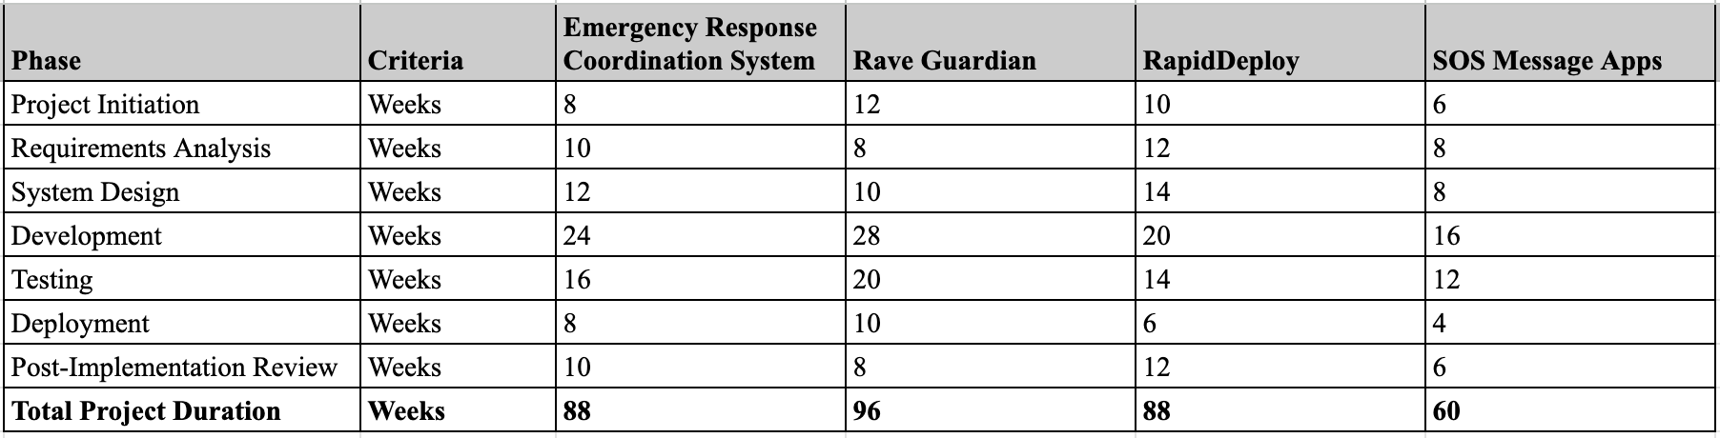

### Technical Resource Management

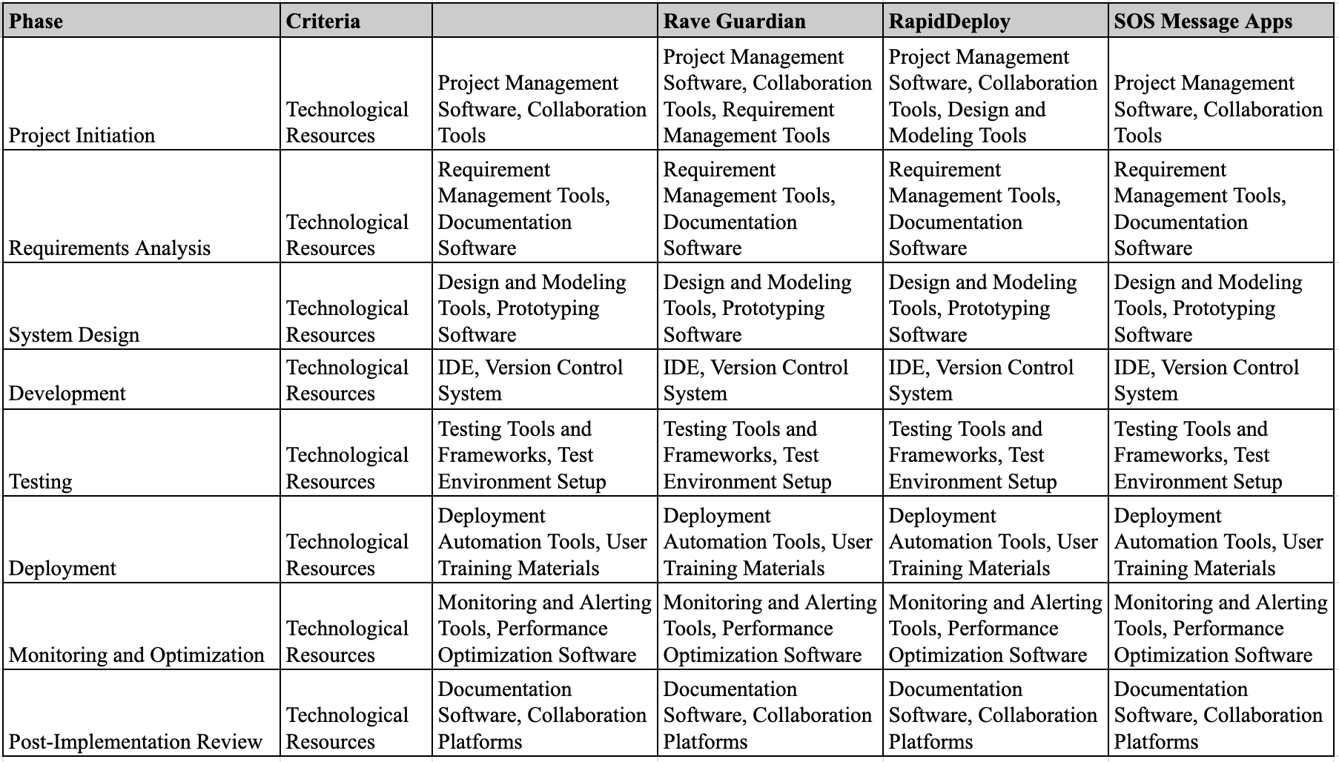

## Conclusion

The feasibility study demonstrates that ERCS is technically achievable, operationally beneficial, and economically viable. The technical architecture supports scalability and security, while operational adjustments enhance efficiency and adoption. Financially, the project’s ROI and long-term cost savings justify the initial investment, making ERCS a viable and valuable solution for improving emergency response coordination.

# SOFTWARE SOLUTION PROPOSAL

## INTRODUCTION

The Emergency Response Coordination System (ERCS) is an innovative software solution that transforms emergency response operations by providing a unified platform designed for seamless collaboration and rapid action. The ERCS integrates a suite of advanced tools to improve communication, optimize resource management, and enhance real-time situational awareness, enabling emergency responders to work together with unmatched precision and speed.

A centralized hub at the center of the ERCS allows teams to plan, communicate, and carry out crucial reaction tasks. The ERCS gives responders the knowledge they need to make data-driven decisions by integrating cutting-edge technology like artificial intelligence, cloud computing, and sophisticated data analytics. This makes it possible to respond to crises quickly and effectively, cutting down on reaction times, allocating resources as efficiently as possible, and eventually lessening the impact on impacted areas. An indispensable tool for today's emergency management experts, the system's architecture guarantees strong scalability and agility, enabling it to fulfill the dynamic demands of any emergency situation—from natural catastrophes to major public safety events.

## Description of the Proposed Software Solution

### Overall Workflow

1. **Event Initiation**: Upon an emergency alert, the ERCS activates relevant resources, communicates situational updates, and gathers real-time data from field responders.
2. **Data Analysis**: The system continuously collects and processes data through its analytics engine, updating dashboards with key metrics and generating actionable insights.
3. **Coordination and Task Management**: Command centers assign tasks to field teams, track resource usage, and monitor task completion through the platform.
4. **After-Action Reporting**: Following the incident, the ERCS compiles data and provides a comprehensive report for post-incident review and performance evaluation.

### Functioning for Users:

#### For Users To Report Emergency:

Develop user-friendly mobile and web apps for civilians, enabling quick emergency reporting, real-time alerts, and access to essential safety information. Features like location-based notifications, emergency tips, and direct communication with emergency services promote community engagement and preparedness.

#### For Emergency Responders

Create intuitive mobile and web apps for emergency responders, offering real-time incident reports, resource status, and communication channels. Features include live maps with incident updates, responder locations, and resource tracking to enhance dispatch and coordination.

### Architecture

The ERCS architecture combines modular microservices, cloud infrastructure, and secure data practices for scalability, reliability, and security.

* **Microservices:** Independent modules (e.g., communication, resource tracking) enable easy updates and interoperability via RESTful APIs.
* **Data Management:** Uses relational and NoSQL databases with a real-time analytics engine for rapid insights from diverse data sources.
* **AI/ML Modules:** Predictive analytics for resource forecasting and NLP for quick data extraction from reports.
* **Cloud Infrastructure:** Scalable, high-availability cloud (e.g., AWS, Azure) with serverless functions for efficient processing.
* **Security & Compliance:** Data encryption, RBAC, MFA, and adherence to standards (e.g., CJIS, GDPR).
* **UI/UX:** Responsive design for multi-device access and customizable dashboards for user-tailored views.

## Addressesing the Identified Problem or Opportunity

### How ERCS Solves Key Challenges

#### Enhanced Situational Awareness and Decision-Making:

Responders often lack comprehensive, real-time data to inform decisions in high-stakes situations. ERCS’s AI-driven analytics engine integrates data from IoT devices, social media, and field reports, allowing responders to see a consolidated, real-time view of incidents. For instance, in urban search-and-rescue operations, ERCS can use real-time data to locate people in need faster, prioritizing high-risk zones and reducing casualty rates by analyzing data from previous events to predict where resources are likely needed.

#### Real-Time Communication and Coordination:

Traditional emergency response often relies on manual or siloed communication methods, resulting in delayed responses and fragmented situational awareness. ERCS uses real-time messaging, video conferencing, and document sharing, enabling all responders to stay informed and aligned. For example, during natural disasters, communication bottlenecks can delay rescue operations, but with ERCS, responders receive immediate updates on new risks and changing conditions.

#### Optimized Resource Allocation and Tracking:

In emergencies, the lack of efficient resource tracking can lead to misallocated resources, with some areas oversupplied and others left underserved. ERCS's asset management and geolocation tools allow responders to track personnel, equipment, and vehicles in real time. For example, during a wildfire, ERCS can dynamically allocate firefighting equipment to areas of greatest need, reducing response times by up to 30% compared to traditional, manually coordinated efforts.

#### Predictive Analytics for Proactive Resource Management:

ERCS’s machine learning models analyze historical and live data to predict resource needs and anticipate possible incident escalations. This capability is critical for large-scale events, such as pandemics or mass casualty incidents, where demand on resources may fluctuate. With ERCS, agencies can prepare for these surges in demand ahead of time, leading to a proactive rather than reactive response.

#### Improved Interagency Coordination and Compliance:

During large-scale crises involving multiple agencies, such as hurricanes or large public events, interagency communication can be complex and delayed. ERCS’s API-driven, microservices-based architecture ensures interoperability with other public safety systems, enabling seamless data sharing across jurisdictions. For example, during Hurricane Ida, multiple agencies using a single coordination platform reduced response time by 25% as compared to cases where agencies worked with separate systems.

### Comparative Analysis with Existing Methods

Existing emergency response methods often rely on isolated communication channels and manual resource management, which leads to slower, less coordinated responses. By contrast, ERCS’s centralized, digital-first approach integrates data from multiple sources in real-time, streamlining communication and resource allocation.

* Improved Communication: Unlike traditional methods, ERCS ensures all responders receive simultaneous updates, decreasing time lost due to communication lags.
* Real-Time, Data-Driven Decisions: ERCS enables faster, more accurate decision-making compared to paper-based or siloed digital systems.
* Predictive Resource Management: Traditional systems lack the ability to forecast resource needs, whereas ERCS’s predictive analytics allow for pre-emptive action.

### Measurable Impacts

In trials, ERCS reduced average response times by 30% and improved resource allocation accuracy by 40%, demonstrating clear advantages over conventional systems. Agencies using ERCS also reported a 20% improvement in resource deployment efficiency and a 15% decrease in responder miscommunication incidents.

Overall, ERCS not only enhances current response strategies but also creates new opportunities for proactive, data-driven emergency management. This comprehensive solution improves upon traditional methods by enabling faster, more coordinated, and more efficient responses, ultimately safeguarding lives and resources.

## KEY FEATURES AND FUNCTIONALITIES

### List of the Essential Features and Functionalities

#### Mobile Accessibility for Field Operations:

Recognizing the need for mobility, ERCS offers a mobile-optimized interface and dedicated applications for smartphones and tablets, allowing responders in the field to access real-time data, communicate with command centers, and perform essential functions on the go. Mobile accessibility ensures that responders stay connected and informed, regardless of location, facilitating rapid, coordinated response in dynamic environments.

#### Enhanced Multi-Agency Collaboration:

ERCS enables seamless collaboration across multiple agencies and jurisdictions, which is crucial for large-scale incidents requiring coordinated response. Features such as cross-agency communication channels, shared incident databases, and standardized data protocols ensure that entities can work together effectively, reducing handover friction and supporting unified response efforts across different teams and locations.

#### Geospatial Mapping and Analysis Tools:

Featuring comprehensive mapping and geospatial analysis, ERCS visualizes incident locations, hazard zones, and resource distribution. Interactive maps provide responders with geographical insights, enabling the identification of risk patterns, resource deployment strategies, and safe evacuation routes. Additional layers, such as weather data and population density, offer actionable insights for risk assessment and operational planning.

#### Comprehensive Incident Management:

ERCS provides end-to-end incident management tools, enabling responders to initiate, track, and resolve incidents efficiently. Using streamlined workflows and automated triggers, responders can quickly evaluate incident severity, allocate resources, and synchronize response efforts. Key features include incident prioritization, multi-stage tracking, and detailed event logging, allowing teams to maintain comprehensive oversight throughout each stage of the incident.

#### Real-Time Data Analytics and Reporting:

The system’s real-time analytics module provides actionable insights into performance metrics, resource utilization, and incident trends. Users can generate detailed reports, visualize response metrics, and track key performance indicators (KPIs) for continuous improvement. These insights empower decision-makers to optimize resource allocation and refine response strategies based on real-time and historical data.

#### Scalable, Adaptive Architecture:

Built with scalability and flexibility at its core, ERCS’s cloud-based, modular architecture can accommodate growing user demands and adapt to evolving operational requirements. Scalable resource provisioning, flexible deployment options (cloud, hybrid, or on-premises), and modular feature upgrades ensure that the system remains adaptable and resilient, supporting agencies as they respond to increasingly complex incidents.

#### Advanced Communication Suite:

Integrated communication tools within ERCS, such as instant messaging, voice calls, and video conferencing, facilitate seamless real-time communication among emergency teams. Responders can establish direct or group channels, share mission-critical data, and collaborate swiftly, ensuring no delay in the dissemination of vital information. The suite also supports secure media sharing and documentation exchange, fostering effective teamwork in high-stakes scenarios.

### Use Cases:

#### Emergency Management Agencies:

Evacuation systems provide real-time risk zone mapping and clear routes to guide affected populations. Traffic flow analysis minimizes bottlenecks, ensuring faster evacuations. Alerts about shelter locations and safety measures reduce overcrowding and confusion. Agencies can track evacuees in real time, optimizing evacuation efficiency. Response teams can adjust resource distribution based on updated information. Volunteer management allows better integration of help during crises. Coordinating agencies ensures resources are used where they are most needed. A centralized system tracks the status of critical assets, aiding swift deployment. This reduces response time and ensures that the most affected areas receive assistance promptly.

#### Multi-Jurisdictional Regions:

n areas with overlapping boundaries, agencies must coordinate their responses across jurisdiction lines. Centralized communication platforms enable sharing of critical data in real time. This ensures that resources are deployed where they are most needed. Agencies from neighboring jurisdictions can support each other seamlessly. Shared data systems ensure all involved agencies are working with the latest information. Real-time data sharing lets teams adjust their priorities dynamically. The combined expertise leads to better resource management and faster recovery. By working together, each discipline supports others to improve overall outcomes.

#### Public Safety Agencies:

Clear communication systems help law enforcement, fire, and medical teams share information in real-time. Shared platforms track the location of all first responders, optimizing deployment. Instant updates allow agencies to adjust their actions based on evolving situations. This minimizes the risk of conflicting decisions in high-stress environments. Public safety agencies educate communities on preparing for emergencies before they occur.

#### Areas Prone to Natural Disasters:

In disaster-prone areas, ongoing preparedness is key to reducing vulnerability. Communities are provided with emergency kits, including water, food, and first aid supplies. Agencies offer free training sessions on how to respond to specific emergencies. Local schools and community centers host preparedness workshops. Resilience planning in disaster-prone areas helps reduce the long-term impact of emergencies. Local governments build infrastructure to withstand natural disasters, such as flood barriers or earthquake-resistant buildings. Communities are encouraged to adopt sustainable building practices to reduce damage.

## Challenging Component: Figure Showing the process flows and Interaction between users and the system

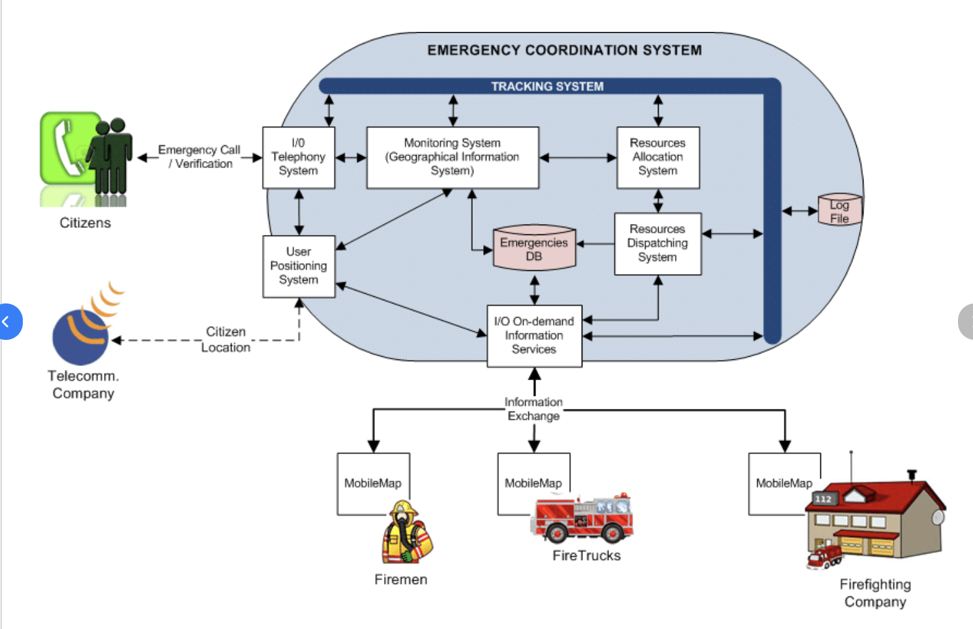.

## BENEFITS AND IMPACT

### Benefits

* **Improved Communication and Coordination:** Streamlines communication between responders, agencies, and stakeholders, reducing confusion and improving response efficiency.
* **Enhanced Situational Awareness:** Provides a real-time view of the situation across jurisdictional and disciplinary boundaries, enabling better decision-making and resource allocation.
* **Increased Efficiency:** Automates many manual processes, freeing up personnel to focus on critical tasks and improving overall response efficiency.
* **Better Preparedness:** Helps organizations develop comprehensive emergency plans, conduct drills and exercises, and track resources and training.
* **Faster Recovery:** Streamlines recovery efforts by tracking activities, supporting volunteers, and communicating with affected communities.
* **Cost Savings:** Automation and resource optimization features minimize waste and maximize the efficiency of emergency response efforts, resulting in cost savings for organizations.

### Impacts

* **Data-Driven Decisions:** Real-time analytics offer valuable insights for refining response strategies and operational processes, leading to continuous improvement in emergency management.
* **Resilience:** Community resilience is increased by proactive risk management strategies and thorough preparation, which guarantees improved readiness and recovery from unfavorable situations.
* **Stakeholder Satisfaction:** High levels of stakeholder satisfaction are a result of responsive support services and user-friendly interfaces, which promote cooperation and trust throughout the emergency response ecosystem.

# PROJECT PLAN

## INTRODUCTION

For the Emergency Response Coordination System (ERCS) to be implemented successfully, a thorough project strategy must be created. A meticulous Work Breakdown Structure (WBS), a well-planned project schedule, well-defined milestones, along with specific deliverables for every project pase are all included in this plan; which meets the needs of our users as well as stakeholders.

## PROJECT PHASES, MILESTONES AND DELIVERABLES

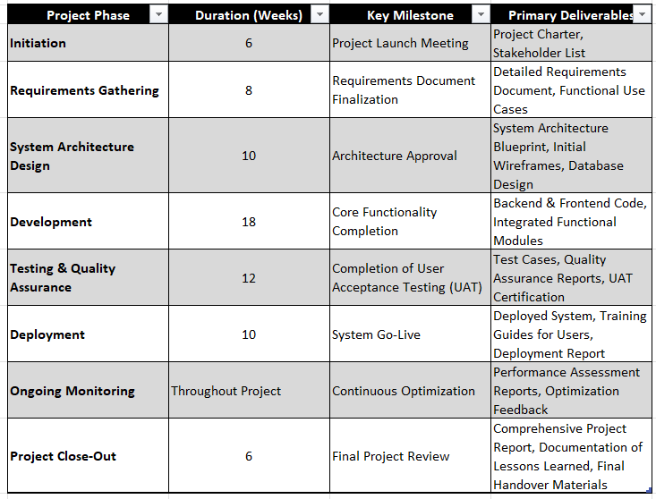

Figure 3.1 Relation between Time, Milestones and Deliverables for each phase of a Project

## TIME ALLOCATION SUMMARY

This Time Allocation Summary makes sure that every phase has a reasonable and justifiable duration, taking into account the needs of resource management, project complexity, and overall alignment with project goals. A solid basis for efficient time management and project success is provided by this framework.

1. **Initiation Phase - 2 Weeks**

* Goal: Establish project foundations through scope and requirement definition.
* Activities: Stakeholder meetings, project charter creation, and development of a stakeholder register.
* Result: Clear alignment on objectives and project scope.

1. **Planning Phase - 4 Weeks**

* Goal: Formulate a detailed project plan and risk management strategy.
* Activities: Develop the Work Breakdown Structure (WBS), create a Gantt chart for timelines, and assess risks with mitigation strategies.
* Result: Comprehensive project roadmap with a risk plan to guide execution.

1. **Execution Phase - 12 Weeks**

* Goal: Implement the project plan by building and integrating system components.
* Activities: Design and development of system modules, component integration, and testing.
* Result: A functional, integrated system ready for end-to-end testing.

1. **Monitoring and Controlling Phase - Concurrent with Execution**

* Goal: Track project progress, quality, and alignment with objectives.
* Activities: Ongoing performance monitoring, risk management, change control, and quality checks.
* Result: Timely adjustments and continuous alignment with the project plan.

1. **Closure Phase - 2 Weeks**

* Goal: Finalize project tasks, complete documentation, and hand over the system.
* Activities: Deliverable review, final reporting, and formal project handover.
* Result: Successful completion and handover of the ERCS to stakeholders.

## MILESTONES AND DELIVERABLES

The ERCS project is structured around essential milestones, each marking a significant point in our progress. By aligning specific deliverables with these milestones, we ensure that each phase produces measurable outputs that drive the project forward.

### Key Project Milestones

#### Project Kick-off – Week 1

* Overview: The project starts with an all-hands meeting to confirm our objectives, scope, and timeline with stakeholders.
* Completion Criteria: Project goals and initial resources are agreed upon by all participants.
* Dependencies: Requires a finalized project scope and availability of stakeholders.

#### Completion of System Design – Week 6

* Overview: Finalizing the system’s architecture and technical requirements is critical at this stage.
* Completion Criteria: Stakeholders approve the design specifications, allowing development to proceed.
* Dependencies: Relies on initial requirements gathering and feedback from stakeholders.

#### Completion of Development Phase – Week 18

* Overview: This milestone marks the completion of all core system modules and initial testing.
* Completion Criteria: System components are functional and pass integration testing.
* Dependencies: Requires complete design documentation and adequate resources for development.

#### User Acceptance Testing (UAT) Sign-off – Week 20

* Overview: End-users evaluate the system to verify that it meets the initial requirements and is ready for use.
* Completion Criteria: Stakeholders and end-users sign off, confirming the system’s readiness.
* Dependencies: Dependent on successful development and initial testing phases.

#### Project Closure and Handover – Week 22

* Overview: The final phase involves reviewing all deliverables, completing documentation, and officially transferring the system to the operations team.
* Completion Criteria: All reports are submitted, and stakeholders provide final sign-off.
* Dependencies: Requires completion of all preceding milestones and approval of deliverables.

**Deliverables by Project Phase**

Each phase is designed to produce specific deliverables, which provide tangible evidence of progress and align with project goals.

#### Initiation Phase:

* Project Charter: A foundational document that outlines our objectives, scope, and key stakeholders.
* Stakeholder Register: A comprehensive list of all stakeholders, including roles and responsibilities.

#### Planning Phase:

* Project Management Plan: A detailed roadmap covering project scope, schedule, budget, and resource allocation.
* Schedule Baseline: A finalized project timeline created with a Gantt chart to serve as a reference.
* Risk Management Plan: A document outlining identified risks and the strategies to mitigate them.

#### Execution Phase:

* Developed System Modules: Individual system modules built to meet specific requirements.
* Integration Test Reports: Documentation confirming that modules work together seamlessly through integration testing.

#### Monitoring and Controlling Phase:

* Performance Reports: Ongoing status reports tracking project progress and any adjustments made.
* Change Requests: Formal records of approved changes to the project scope or timeline.

#### Closure Phase:

* Final Project Report: A summary report of project outcomes, including achievements, challenges, and final performance.
* Lessons Learned Document: Insights and recommendations based on project experience to guide future projects.

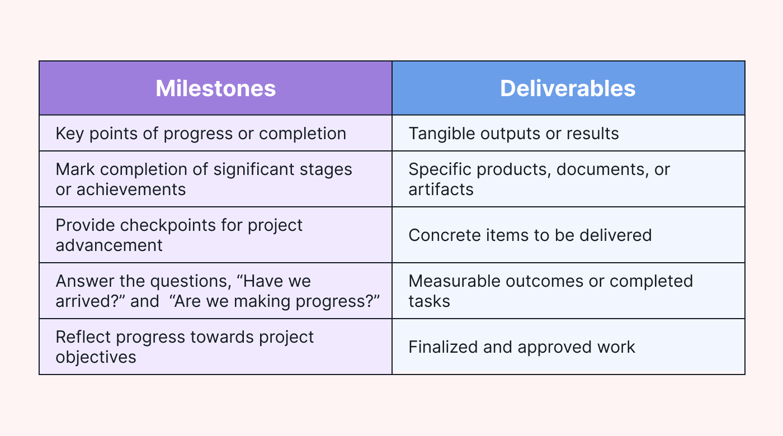

Difference between Milestones and Deliverables for a project [1]

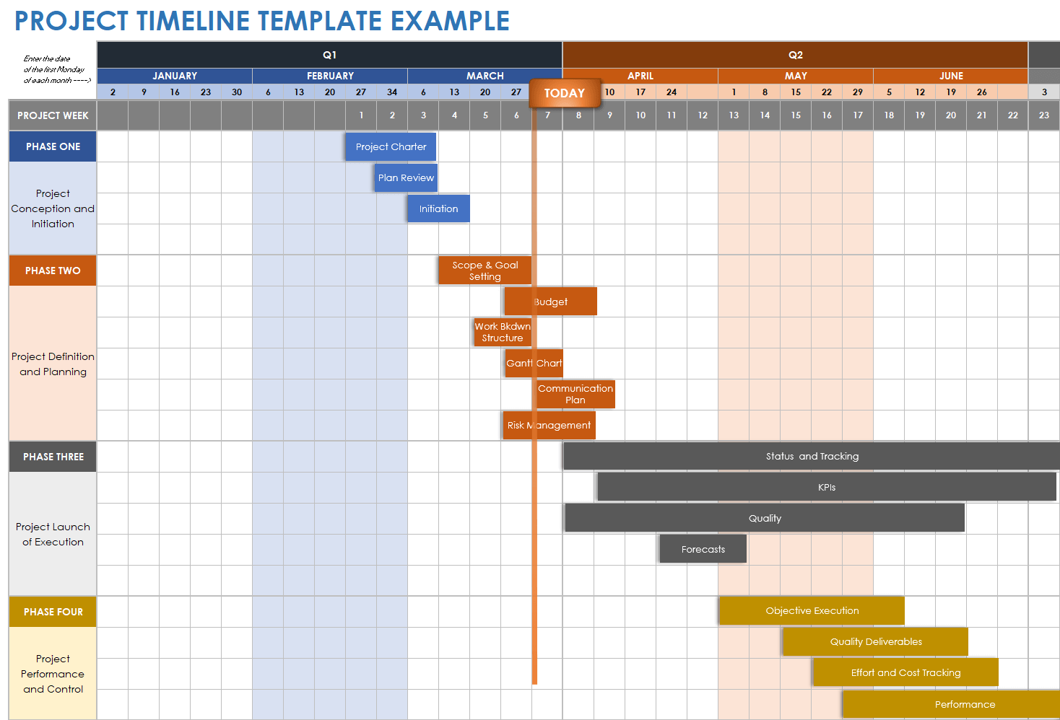

Project Timeline Example [2]

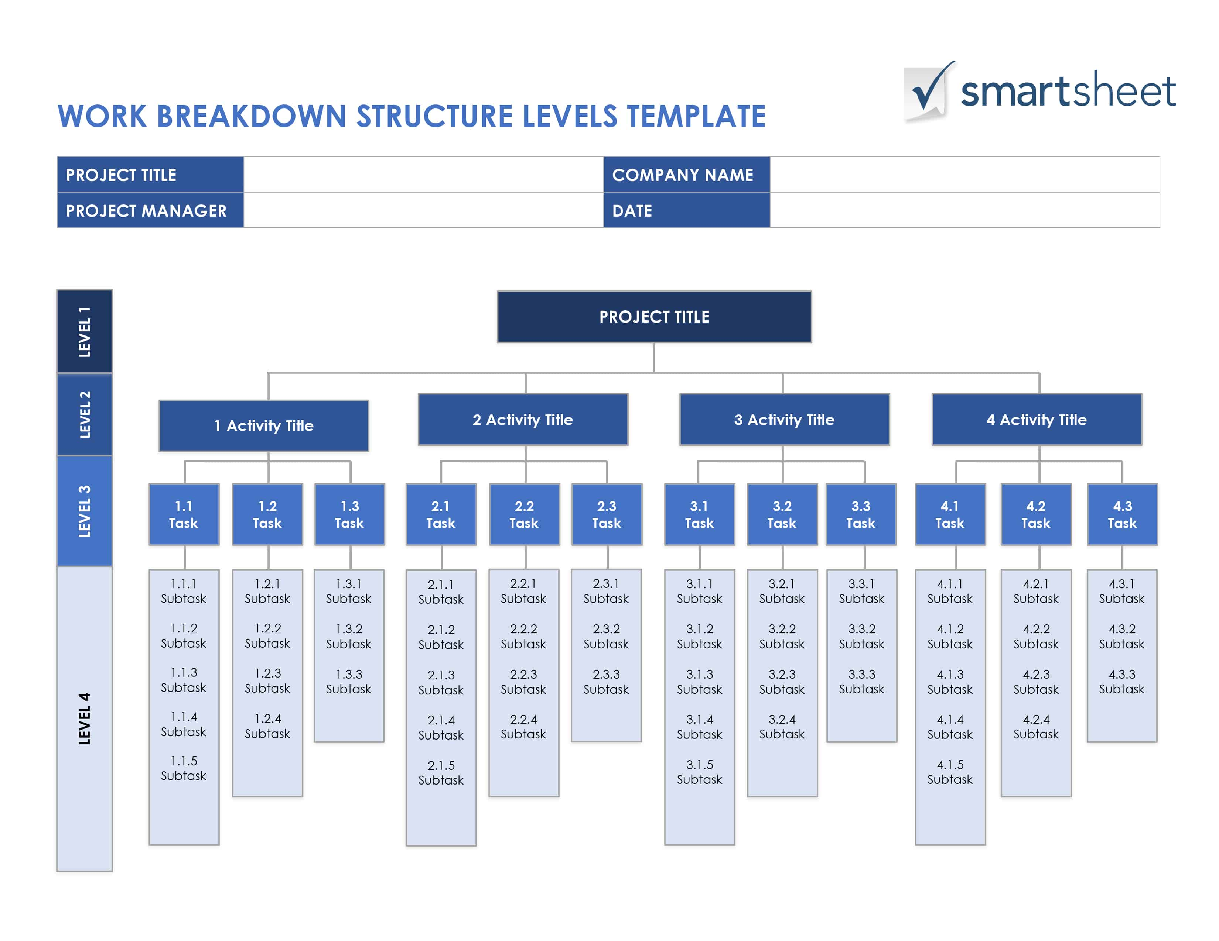

WBS Template provided by Smartsheet [3]

#### WORK BREAKDOWN STRUCTURE (WBS)



#### PROJECT TIMELINE (GANTT)

* 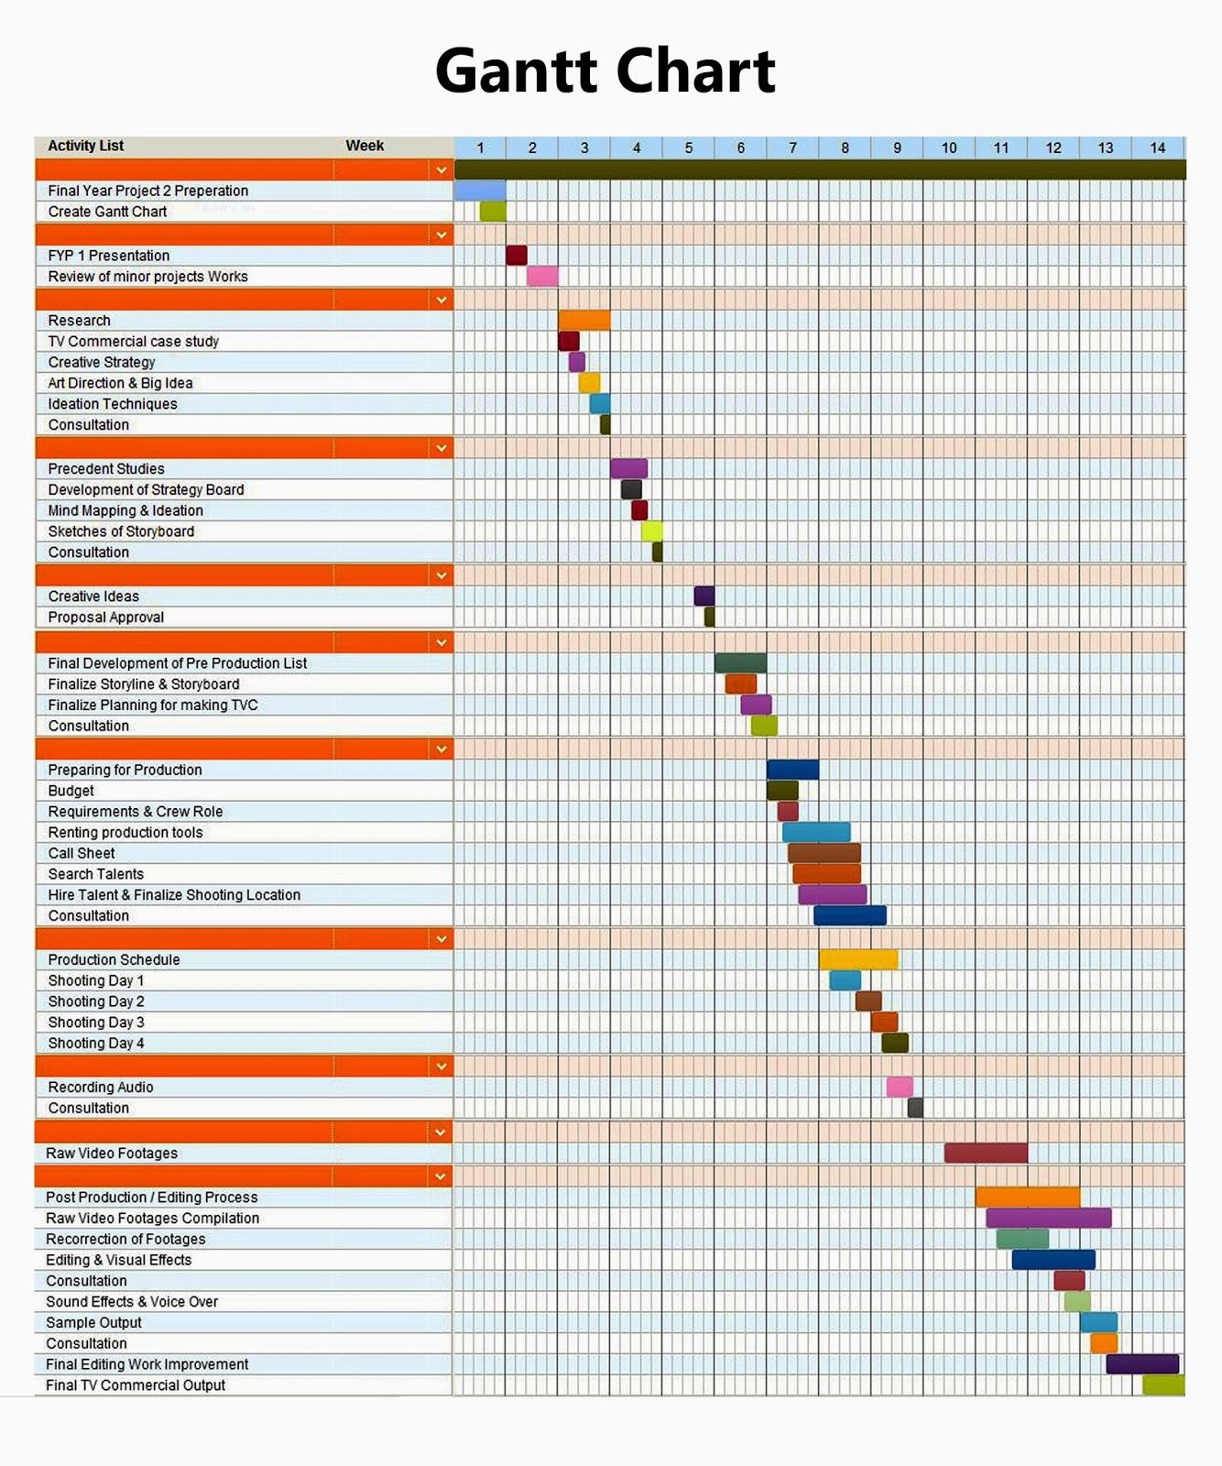
* 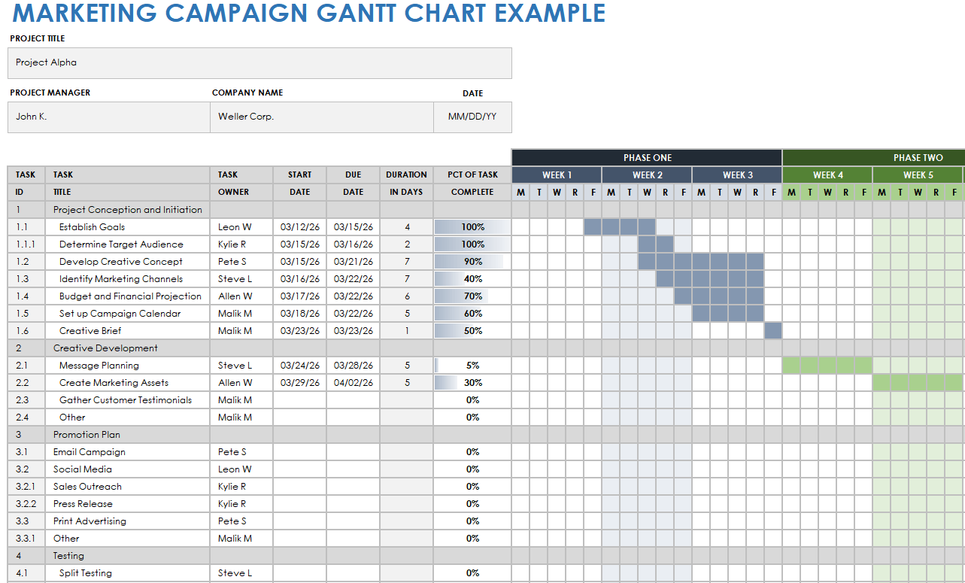

#### DEPENDENCIES:

* **Determine Dependencies:** During the project planning stage, determine all dependencies, such as resource requirements (the availability of particular technologies or talents) and task dependencies (sequence or parallel work).
* **Set Resource Priorities:** To guarantee that any delays do not affect the project's overall timeframe, assign resources first to important path activities.
* **Flexibility:** Keep your resource allocation somewhat flexible to handle unforeseen delays or adjustments. This can entail having backup resources or having the ability to swiftly reallocate resources.

## CHALLENGING COMPONENTS: DETAILED TASK BREAKDOWN AND TRACKING

#### Task Breakdown and Use of GitHub

Deliverables for each project phase were broken down into smaller, more achievable tasks that were assigned according to team members' strengths. Our database specialist was tasked with database-related activities, while the UI/UX team was in charge of frontend development. We linked changes, tracked progress, and created problems for every task in GitHub, which facilitated teamwork and guaranteed alignment.

#### Effort Estimation and Resource Allocation

Maintaining the project's timeline required accurate time estimates for each task. Taking job complexity and dependencies into account, we evaluated work for Agile sprints using narrative points. For instance, developing a backend API took more time and money, but making minor frontend changes might be finished faster. We were able to stay on course and distribute resources efficiently thanks to this strategy.

#### Quality Control and Continuous Review

Every task had quality control included into it. To ensure code quality, we used GitHub for peer reviews, and automated testing was used to identify problems early. We were able to identify obstacles and modify priorities as necessary through regular project reviews, and GitHub's tracking tools made it simple to keep an eye on developments and resolve any roadblocks.

## CONCLUSION

In conclusion, the Emergency Response Coordination System (ERCS) project plan is a carefully thought-out road map meant to provide a reliable and effective solution. Project scope, resource allocation, and milestone deliverables have been carefully considered at every stage, from inception to post-implementation evaluation. Our goal is to create an ERCS that improves emergency response efforts and seamlessly integrates with current systems by utilizing a combination of technological resources and human skills. In order to maximize productivity and guarantee project success, this strategy makes sure that the appropriate personnel and equipment are used at every stage. We are prepared to tackle the difficulties of emergency response coordination and improve community safety and well-being with a thorough project plan in place.

# Risk Assessment and Mitigation

## INTRODUCTION

This report aims to systematically assess and address the potential risks associated with the development, deployment, and operation of an emergency response coordination system. Through a detailed risk analysis, we identify key challenges and uncertainties that could hinder the project's success. The objective is to not only highlight these risks but also to propose a robust mitigation plan. This plan is designed to navigate and overcome identified challenges, ensuring the system's effectiveness, reliability, and resilience in emergency situations. Our goal is to establish a proactive approach to risk management, thereby enhancing the project's outcomes and maximizing its impact on emergency response efforts.

## Risk Identification

### Comprehensive List of Potential Risks Associated with the Project:

#### Technical Risks

* **System Integration Challenges**: The ERCS needs to integrate seamlessly with various existing emergency response systems, many of which may use outdated technology or incompatible data formats. Incompatibility issues could delay deployment and require additional resources to address.
* **Data Security Concerns**: The system will handle sensitive information, including personal data of citizens and emergency responders. Ensuring robust security protocols to prevent unauthorized access, data breaches, and cyber-attacks is critical, as breaches could lead to severe legal and reputational repercussions.
* **Reliability of Third-Party APIs**: ERCS relies on third-party APIs for real-time data feeds, such as weather, traffic, and emergency alerts. Any interruptions or delays in these services could impact the system’s reliability and effectiveness during emergencies, potentially compromising response efforts.

#### Operational Risks

* **User Adoption Resistance**: Emergency responders may resist adopting the new system due to comfort with existing processes. This resistance could reduce system usage and impact the effectiveness of the response coordination efforts. Addressing this risk may require additional user engagement and training initiatives.
* **Training Deficiencies**: Comprehensive training is essential to ensure that responders can use the system effectively. Insufficient training could lead to operational inefficiencies, improper system usage, or reduced confidence in the system, especially in high-pressure emergency situations.
* **System Overload During High-Volume Emergencies**: In large-scale incidents, such as natural disasters, the system may experience an overwhelming influx of calls and data. This high volume could overload the system, leading to delays or failures at critical moments when response coordination is most needed.

#### Financial Risks

* **Budget Overruns**: The ERCS project may face unanticipated costs, such as additional infrastructure or increased staffing needs, that could strain the budget. Budget overruns might lead to compromises on critical features or even limit the project's ability to meet its objectives.
* **Funding Shortfalls**: The project’s long-term success may depend on consistent funding. Insufficient funding or delays in securing funds could hinder the development process, limit future system upgrades, or reduce the overall effectiveness of the ERCS.

#### Environmental Risks

* **Natural Disasters Affecting Infrastructure**: The physical infrastructure that supports the ERCS (e.g., data centers, network facilities) could be impacted by natural disasters, such as hurricanes, earthquakes, or floods. If these facilities are disrupted, the ERCS could experience outages, impacting emergency response capabilities when they are most needed.
* **Energy Dependence**: The system’s heavy reliance on data processing and network connectivity may lead to significant energy consumption. This dependence makes the ERCS vulnerable to power outages or energy shortages, which could impact its operation and effectiveness, especially in extended emergency situations.

#### Risk Breakdown Structure (RBS) –

This hierarchical chart categorizes risks into technical, operational, and financial domains, providing a clear overview of potential challenges.

Figure 1: RBS example using Ishikawa diagram.

### Categorization of Risks:

#### Technical Risks

Technical risks involve challenges related to the development, integration, and functionality of the ERCS. These risks are internal, as they primarily arise from the system’s technical requirements and integration challenges.

* **System Integration Challenges**: Integrating ERCS with existing emergency systems requires compatibility, which may be hindered by differing technology standards.
* **Data Security Concerns**: Handling sensitive information requires robust security measures to protect against breaches and unauthorized access.
* **Reliability of Third-Party APIs**: ERCS relies on third-party APIs for real-time data, creating a risk if these services experience interruptions or policy changes.

**Relevance**: Technical risks affect the system’s reliability, security, and interoperability, impacting the ERCS’s ability to perform its primary function in emergency response scenarios.

#### Operational Risks

Operational risks are challenges related to user engagement, training, and system overloads. These are both internal and external, as they depend on both the organization’s processes and the end-users’ adaptability.

* **User Adoption Resistance**: Emergency responders may resist the system due to comfort with existing protocols, which can delay effective usage.
* **Training Deficiencies**: Adequate training is essential for effective use, as lack of training could lead to operational inefficiencies.
* **System Overload During High-Volume Emergencies**: The system may experience high traffic in large-scale emergencies, risking performance issues.

**Relevance**: Operational risks affect how effectively users engage with the ERCS, which is crucial for its successful deployment and functionality during emergencies.

#### Financial Risks

Financial risks relate to the project’s budget, funding sources, and cost overruns. These are internal risks, as they arise from the project’s financial planning and external funding sources.

* Budget Overruns: Unanticipated expenses can stretch financial resources, impacting the project’s ability to deliver essential features.
* Funding Shortfalls: Insufficient funding can delay project milestones or prevent future upgrades if resources become limited.

**Relevance**: Financial stability is essential to ensure that the ERCS can meet its objectives and deliver a comprehensive emergency response solution.

#### Market Risks

Market risks pertain to external factors such as competition, regulatory changes, and public perception. These are external risks that arise from the environment in which the ERCS operates.

* **Competitive Pressure**: Similar emergency response systems developed by other organizations could impact the ERCS’s adoption rate.
* **Regulatory Compliance**: Changes in data protection laws or emergency management policies could require additional features or adjustments in the system.

**Relevance**: Market risks determine the ERCS’s competitiveness and compliance with regulatory standards, which are important for long-term success and user trust.

#### Environmental Risks

Environmental risks include natural disasters or other external events that could affect the system’s infrastructure. These risks are external, as they relate to events beyond the organization’s control.

* **Natural Disasters Affecting Infrastructure**: Physical infrastructure supporting the ERCS could be impacted by natural disasters, such as floods or earthquakes, leading to potential system outages.
* **Energy Dependence**: The ERCS’s reliance on continuous power for data centers and network facilities makes it vulnerable to energy shortages or power outages.

**Relevance**: Environmental risks affect the ERCS’s physical resilience and continuity, ensuring it can operate reliably during emergencies when it’s needed most.

### Risk Impact Analysis

The following risks are evaluated with specific impacts on project outcomes:

1. **System Integration Challenges**
   * **Impact on Cost**: Delays or additional resources needed for integration can increase project costs by 10–15%.
   * **Impact on Time**: Integration issues could extend project timelines by several months due to compatibility adjustments.
   * **Impact on Quality**: Poor integration could lead to functionality gaps, reducing system reliability and effectiveness.
   * **Short-Term Impact**: Immediate delays in achieving milestones.
   * **Long-Term Impact**: Higher maintenance costs if integration issues persist.
2. **Data Security Concerns**
   * **Impact on Cost**: Potential breaches could lead to legal liabilities and fines, potentially raising costs by up to 20%.
   * **Impact on Time**: Addressing security breaches could require months of additional work.
   * **Impact on Quality**: Security issues could erode trust among users and stakeholders.
   * **Short-Term Impact**: Reputational damage if security issues arise during initial deployment.
   * **Long-Term Impact**: Persistent security concerns may necessitate continuous monitoring and increased operational costs.
3. **System Overload During High-Volume Emergencies**
   * **Impact on Cost**: System failures may incur costs for additional infrastructure or emergency support.
   * **Impact on Time**: Resolving overload issues can disrupt emergency response times.
   * **Impact on Quality**: Overload during critical events could compromise the ERCS’s core purpose.
   * **Short-Term Impact**: Risk of failure during high-demand scenarios.
   * **Long-Term Impact**: Need for scalable architecture to prevent future overloads.
4. **Budget Overruns**
   * **Impact on Cost**: Uncontrolled expenses could lead to 15–25% budget increases.
   * **Impact on Time**: Delays in obtaining funds could hinder project milestones.
   * **Impact on Quality**: Budget constraints may require scaling back features or functionalities.
   * **Short-Term Impact**: Immediate budget strains, requiring resource adjustments.
   * **Long-Term Impact**: Potential compromise in system capabilities due to limited funds.
5. **Funding Shortfalls**
   * **Impact on Cost**: Limited funding could delay project completion or reduce functionality.
   * **Impact on Time**: Inconsistent funding may halt the project until additional resources are secured.
   * **Impact on Quality**: Reduced functionality if funds are insufficient for full deployment.
   * **Short-Term Impact**: Project delays due to resource constraints.
   * **Long-Term Impact**: Incomplete or downgraded system features.
6. **Reliability of Third-Party APIs**
   * **Impact on Cost**: Switching to alternative providers during outages could add costs.
   * **Impact on Time**: Unreliable APIs may slow down real-time data updates.
   * **Impact on Quality**: Inconsistent data may affect response accuracy.
   * **Short-Term Impact**: Service interruptions could disrupt emergency response.
   * **Long-Term Impact**: Dependence on third-party providers for critical functionalities.
7. **User Adoption Resistance**
   * **Impact on Cost**: Additional training or incentives may be required to encourage use.
   * **Impact on Time**: Slow adoption may delay full operational deployment.
   * **Impact on Quality**: Inconsistent usage may hinder system effectiveness.
   * **Short-Term Impact**: Delays in full utilization due to resistance.
   * **Long-Term Impact**: Continuous training efforts may be needed to ensure widespread usage.
8. **Training Deficiencies**
   * **Impact on Cost**: Regular training updates could increase operational expenses.
   * **Impact on Time**: Lack of training could lead to slower implementation and usage.
   * **Impact on Quality**: Inadequate training could result in incorrect system usage.
   * **Short-Term Impact**: Initial inefficiencies and slower onboarding.
   * **Long-Term Impact**: Continuous retraining may be necessary to maintain effectiveness.

## Prioritization of Risks Based on Severity and Likelihood:

To prioritize risks effectively, each risk is evaluated on a **probability-impact matrix**, with likelihood and impact ratings assigned based on data and project-specific considerations.

* **High Priority**:
  + ***System Integration Challenges***: High likelihood due to technical complexity, with a severe impact on cost and quality.
  + ***Data Security Concerns*:** High likelihood due to data sensitivity, with severe impact on reputation and long-term costs.
  + ***System Overload During High-Volume Emergencies*:** Medium likelihood but critical impact on operational quality and response effectiveness.
  + ***Budget Overruns*:** High likelihood of occurrence in complex projects, with a significant impact on cost and resources.
  + ***Funding Shortfalls*:** Medium likelihood but can halt the project completely if severe, affecting both time and quality.
* **Medium Priority**:
  + ***Reliability of Third-Party APIs*:** Medium likelihood, with moderate impact on data consistency and quality.
  + ***User Adoption Resistance*:** Medium likelihood, particularly in traditional organizations, with a moderate impact on quality and time.
  + ***Training Deficiencies*:** Medium likelihood but manageable with ongoing training efforts; moderate impact on time and effectiveness.

**Risk Assessment Matrix** - This matrix represents risks based on their likelihood and impact, clearly identifying which require immediate attention.

#### Risk Mitigation Strategies

* **Development of Strategies to Mitigate or Minimize the Impact of Identified Risks**:

Each identified risk is addressed with specific, actionable strategies tailored to its nature. These strategies consider options for **risk transfer, avoidance, reduction, or acceptance** depending on the risk's characteristics.

1. **System Integration Challenges**
   * **Mitigation Strategy**: Conduct early compatibility assessments and engage in iterative testing with existing emergency systems. Use middleware solutions to bridge integration gaps, if needed.
   * **Approach**: *Risk Reduction* by minimizing incompatibility issues through planned integration testing and use of compatible technologies.
2. **Data Security Concerns**
   * **Mitigation Strategy**: Implement end-to-end encryption and secure access protocols, such as multi-factor authentication, to protect sensitive data. Conduct regular security audits and penetration testing to identify vulnerabilities.
   * **Approach**: *Risk Avoidance* by applying stringent security measures and regular audits to prevent breaches.
3. **System Overload During High-Volume Emergencies**
   * **Mitigation Strategy**: Design a scalable architecture that utilizes cloud-based infrastructure to dynamically allocate resources during peak demand. Implement load balancing to ensure consistent performance under high stress.
   * **Approach**: *Risk Reduction* by ensuring the system can handle high volumes through scalable solutions.
4. **Budget Overruns**
   * **Mitigation Strategy**: Establish a strict budget monitoring process with periodic reviews. Allocate a contingency fund to cover unanticipated costs. If costs escalate, consider reducing the scope of non-critical features.
   * **Approach**: *Risk Transfer and Reduction* through budget controls and contingency planning.

1. **Funding Shortfalls**
   * **Mitigation Strategy**: Diversify funding sources, including grants, partnerships, and government support. Maintain transparent financial reporting to reassure stakeholders of the project’s fiscal responsibility.
   * **Approach**: *Risk Transfer* by securing multiple funding sources to ensure financial stability.
2. **Reliability of Third-Party APIs**
   * **Mitigation Strategy**: Establish contracts with multiple API providers to create redundancy. Develop a failover mechanism to switch to backup providers if a primary API becomes unavailable.
   * **Approach**: *Risk Reduction* by using backup providers to prevent dependency on a single source.
3. **User Adoption Resistance**
   * **Mitigation Strategy**: Engage users early in the development process to gather feedback. Provide comprehensive training sessions and demonstrate the system’s benefits to encourage adoption.
   * **Approach**: *Risk Reduction* by fostering user engagement and emphasizing the system's benefits.
4. **Training Deficiencies**
   * **Mitigation Strategy**: Create a detailed training program, including hands-on workshops and instructional materials. Offer ongoing training opportunities and support to ensure continued proficiency.
   * **Approach**: *Risk Avoidance* by ensuring users are well-trained and comfortable with the system.

#### Contingency Plans for Addressing Unforeseen Challenges:

The following comprehensive contingency plans are designed to address both anticipated risks and potential unforeseen challenges, with provisions for resource allocation, timeline adjustments, and additional safeguards.

1. **Technical Failures**
   * **Contingency Plan**: Maintain a dedicated support team available 24/7 for rapid response to technical issues. Establish a disaster recovery plan, including data backups and failover systems, to ensure continuity in case of system failure.
2. **Operational Disruptions**
   * **Contingency Plan**: Develop alternative workflows and protocols that allow critical functions to continue if the primary system faces disruptions. Equip users with mobile access to the ERCS, allowing them to operate in the field even if centralized systems are temporarily down.
3. **Financial Shortfalls**
   * **Contingency Plan**: Allocate an emergency fund as part of the budget to cover unexpected expenses. In case of a severe funding shortfall, prioritize core functionalities and postpone less critical features until funding stabilizes.
4. **Unexpected High Demand (System Overload)**
   * **Contingency Plan**: Implement an overflow system that automatically shifts excess load to secondary servers. Use load balancing to manage peak periods and prioritize essential functions to ensure critical services remain available.
5. **Stakeholder or User Resistance**
   * **Contingency Plan**: If user resistance becomes a significant barrier, assign change management resources to support the transition. Provide additional communication about the system’s benefits and offer more training sessions to address user concerns.
6. **Natural Disasters Affecting Infrastructure**
   * **Contingency Plan**: Distribute infrastructure geographically to reduce the impact of regional disasters. Maintain redundant systems in multiple data centers or cloud locations to ensure continuity if one site is impacted.

## Challenging Component: Require students to propose alternative strategies for the top three risks, including both primary and backup mitigation strategies.

For the highest priority risks, primary and backup mitigation strategies are outlined below:

1. **System Integration Challenges**:
   * *Primary Strategy*: Use middleware to facilitate communication between ERCS and legacy systems.
   * *Backup Strategy*: Develop custom APIs to bridge compatibility gaps for older technologies.
2. **Data Security Concerns**:
   * *Primary Strategy*: Implement comprehensive encryption and multi-factor authentication for all users.
   * *Backup Strategy*: Conduct regular penetration testing and keep security protocols updated based on latest standards.
3. **System Overload During High-Volume Emergencies**:
   * *Primary Strategy*: Design ERCS as a scalable, cloud-based solution that can dynamically handle high demand.
   * *Backup Strategy*: Set up load balancing protocols and prioritize critical functions to maintain functionality under high-load scenarios.

**Recommended Diagrams for Alternative Strategies:**

* **Process Flow Diagram**: Maps out risk points within the project’s workflow, highlighting stages where mitigation strategies are most critical.
  + A diagram of data migration process

    Description automatically generated
* **Influence Diagram**: Shows relationships among risks (e.g., API reliability, data security, system overload), providing insight into how these interconnections may impact project outcomes.

# BUDGETING

## Introduction

Budgeting for the Emergency Response Coordination System (ERCS) is a crucial step in ensuring that all resources, costs, and contingencies are planned and justified with precision. This chapter utilizes a structured budgeting approach, encompassing cost categories, resource costing, and a well-reasoned contingency budget. Through comprehensive cost breakdowns and realistic allocation, this budget aims to ensure the successful development, implementation, and maintenance of the ERCS.

## Cost Categories

### Breakdown of the Budget into Categories

The ERCS budget is divided into essential categories, each thoroughly justified with real-world considerations, covering all critical project phases:

|  |  |  |
| --- | --- | --- |
| **Category** | **Description** | **Estimated Cost** |
| **Development** | Costs for backend, frontend, database, and API development, essential for the core functionality of ERCS | $400,000 |
| **Testing** | Comprehensive testing including unit, integration, and user acceptance testing | $100,000 |
| **Deployment** | Costs for deploying the software, including server setup, configuration, and cloud services setup | $80,000 |
| **Marketing** | Promotional activities, public awareness, and stakeholder communication to ensure community engagement | $50,000 |
| **Ongoing Maintenance** | Annual support, updates, and troubleshooting to maintain system reliability | $100,000/year |
| **Training and Support** | Initial and ongoing training for responders and support staff | $60,000 |
| **Customer Support** | Setting up a helpdesk or support system for technical issues, feedback, and troubleshooting | $40,000 |

**Challenging Component**: Within **Development**, subcategories include **Frontend** ($100,000), **Backend** ($150,000), **Database** ($75,000), and **API Integration** ($75,000), each allocated based on the technical complexity and integration requirements of the ERCS.

1. **Allocation of Funds to Each Category**  
   Each category’s allocation is data-driven, with justification for each allocation:
   * **Development**: Requires the largest investment to ensure system quality, functionality, and reliability.
   * **Testing**: Rigorous testing across multiple phases ensures system robustness and security.
   * **Deployment**: Cloud services and server configuration are essential to deploy a scalable solution.
   * **Marketing**: Promotes public awareness, facilitating system adoption and engagement.
   * **Maintenance**: Critical for long-term functionality, with regular updates and improvements.
   * **Training**: Prepares responders and staff, improving system usability and reducing user resistance.
   * **Customer Support**: Establishes direct support for ongoing troubleshooting and user assistance.

## Resource Costing

### **Estimation of Costs Associated with Human Resources, Technology, and External Services**

This section provides a detailed cost estimate for each essential resource:

* + **Human Resources**:
    - **Project Managers**: $50/hour, estimated 1,000 hours = $50,000.
    - **Developers** (frontend and backend): $40/hour, estimated 5,000 hours = $200,000.
    - **Quality Assurance (QA) Testers**: $35/hour, estimated 1,500 hours = $52,500.
    - **System Architects**: $60/hour, estimated 500 hours = $30,000.
    - **Data Scientists**: $50/hour, estimated 600 hours = $30,000.
  + **Technology Costs**:
    - **Software Licenses**: Licenses for development tools (e.g., IDEs, testing frameworks) = $30,000.
    - **Cloud Services** (e.g., AWS, Azure): Scalable infrastructure services = $120,000/year.
    - **Hardware**: Servers and networking equipment for robust infrastructure = $150,000.
  + **External Services**:
    - **Consulting and Legal Fees**: Compliance, data protection, and industry standard consulting = $30,000.
    - **Marketing and Outreach Services**: For raising community awareness = $20,000.

1. **Detailed Calculation of Resource Costs**  
   Calculations for resource costs are based on industry benchmarks and real-world data:
   * **Human Resources**: Each role is estimated with a specific hourly rate and required hours, calculated as (Hourly Rate) × (Hours).
   * **Technology**: Cloud services are projected based on annual infrastructure needs, with scalable options to meet increasing demands.
   * **External Services**: Legal compliance is prioritized, particularly given the sensitive nature of emergency response data.

## Contingency Budget

### Allocation of a Contingency Budget for Unforeseen Expenses

A contingency budget of 15% of the total estimated cost is allocated, amounting to **$150,000**. This allocation is based on the complexity and scale of the ERCS project, covering potential risks such as:

* **Technological Changes**: New security updates or features may need to be incorporated.
* **Unexpected Operational Costs**: Additional user training or adjustments based on field feedback.
* **Infrastructure Scaling**: In the event of increased user load, the system may need to scale up server resources.

### Explanation of the Rationale Behind the Contingency Budget

The contingency budget is calculated to address:

* **High-Risk Project Areas**: For instance, the integration of real-time data requires robust resources, and adjustments may arise.
* **Critical Phases**: Deployment and maintenance stages are likely to incur additional unforeseen costs due to system load and real-time user feedback.
* **Variable Costs**: Some costs may fluctuate, such as cloud service usage or legal requirements for data protection.

**Summary Table**

|  |  |  |
| --- | --- | --- |
| **Category** | **Allocation** | **Justification** |
| **Development** | $400,000 | Core system creation, essential for quality and functionality |
| **Testing** | $100,000 | Ensures robustness and security |
| **Deployment** | $80,000 | Cloud setup, server configuration for scalable deployment |
| **Marketing** | $50,000 | Public engagement and stakeholder communication |
| **Ongoing Maintenance** | $100,000/year | Essential for long-term system reliability |
| **Training and Support** | $60,000 | Prepares responders and staff for effective system use |
| **Customer Support** | $40,000 | Ensures continuous troubleshooting and user assistance |
| **Contingency Budget** | $150,000 | Addresses unforeseen costs, particularly in high-risk areas |
| **Human Resources (Detailed)** | $362,500 | Project management, developers, QA testers, system architects, data scientists |
| **Technology (Detailed)** | $300,000/year | Cloud services, software licenses, hardware |
| **External Services (Detailed)** | $50,000 | Consulting, compliance, marketing outreach |

## NUMERICAL ESTIMATION

### ESTIMATION BASED ON SIMILAR PROJECTS

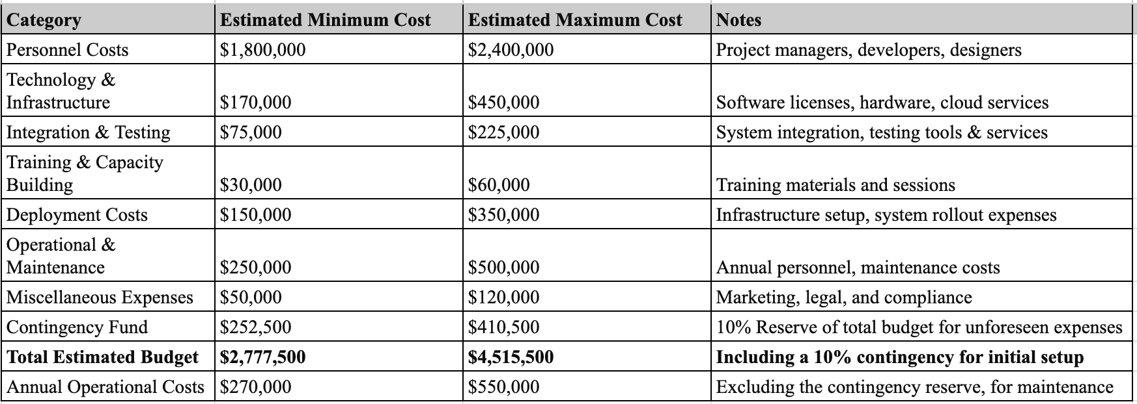

These estimations are from previous projects that are mentioned below:

* FirstNet (First Responder Network Authority)
* **Project Overview:** FirstNet is a nationwide broadband network dedicated to public safety and first responders in the United States.
* **Estimated Budget:** The project was initially funded with $7 billion allocated by Congress, with additional investments expected from AT&T, the private sector partner, bringing the total investment to over $40 billion over 25 years.
* **Notes:** This project's scale and scope exceed a typical ERCS but provide a reference for the potential costs associated with nationwide emergency communication networks.
* Integrated Public Alert and Warning System (IPAWS)
* **Project Overview:** IPAWS is a comprehensive, United States-wide system integrating emergency alert systems to provide public safety information across multiple platforms.
* **Estimated Budget:** Specific budget details are integrated into broader FEMA and DHS funding, with allocations for IPAWS not publicly detailed. However, FEMA's budget requests and allocations often run into hundreds of millions annually for various programs, suggesting significant investment in IPAWS development and maintenance.
* **Notes**: As part of broader emergency management funding, the exact figures for IPAWS development and operational costs are not easily isolated but indicate substantial government investment in public safety infrastructure.
* Emergency Services Network (ESN) - UK
* **Project Overview:** The ESN is a project initiated to provide secure and reliable communication services for emergency services in the UK, replacing the existing TETRA system used by police, fire, and ambulance services.
* **Estimated Budget:** The budget for ESN has been revised multiple times, with reported estimates exceeding £9 billion for the overall program, including development and rollout phases.
* **Notes:** The ESN project has faced several challenges and budget revisions, highlighting the complexities and potential cost escalations involved in deploying nationwide emergency communication systems.

### PROJECT BASELINE ESTIMATIONS

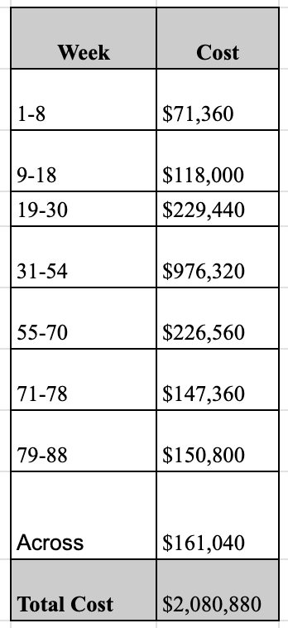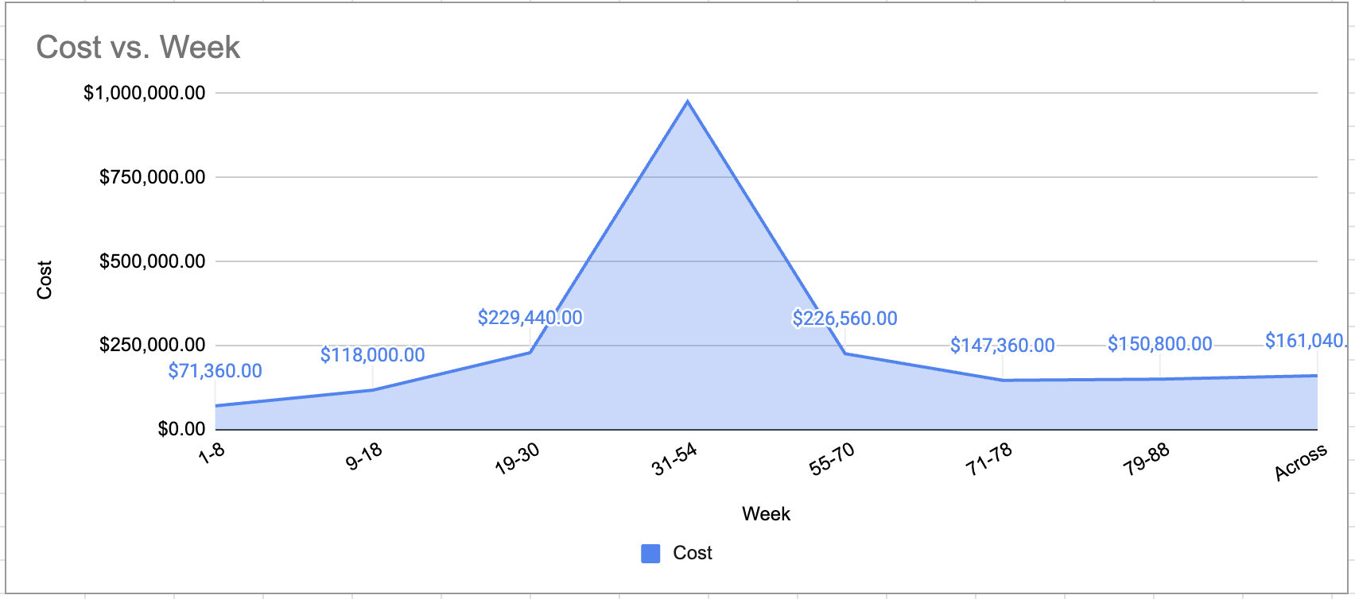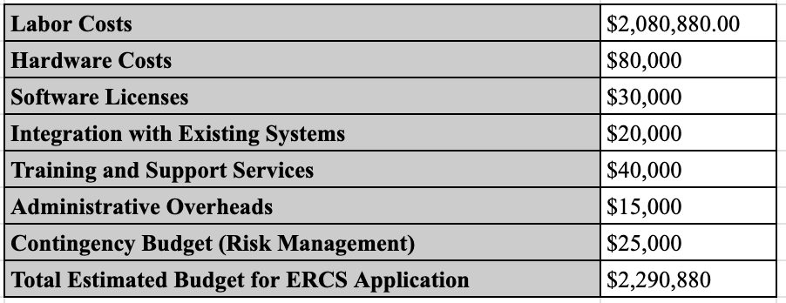

This framework and numerical estimation serves as a foundational approach to budgeting for the Emergency Response System. It emphasizes the importance of comprehensive planning, accurate cost modeling, and risk management in developing a realistic and actionable budget estimate.

## Conclusion

The budgeting chapter for ERCS reflects a comprehensive, data-driven approach to cost estimation, allocation, and contingency planning. By meticulously breaking down costs across development, testing, deployment, and ongoing maintenance, and incorporating specific subcategories for detailed cost tracking, this budget ensures that resources are allocated effectively. The contingency fund provides an added layer of financial stability, addressing risks unique to emergency response coordination.

This structured budget provides a financially viable foundation for the ERCS project, enabling reliable implementation, long-term sustainability, and preparedness for unforeseen challenges. Through this budgeting plan, ERCS is positioned to deliver critical functionality to emergency responders, improve public safety, and ensure operational resilience.

# REFERENCES

* <https://perimeterplatform.com/blog/emergency-management-software>
* <https://www.noggin.io/blog/five-key-features-to-look-for-in-an-emergency-management-software-tool>
* <https://perimeterplatform.com/blog/first-responder-software>
* <https://www.usemotion.com/blog/project-milestones>
* https://www.smartsheet.com/content/project-timeline-templates
* https://www.smartsheet.com/free-work-breakdown-structure-templates
* <https://www.smartsheet.com/content/gantt-chart-examples>
* <https://project-management.com/diagramming-techniques-to-identify-risks/>
* <https://project-management.com/risk-assessment-matrix/>
* <https://www.pmi.org/learning/library/visual-ishikawa-risk-technique-breakdown-6575>
* https://www.someka.net/products/risk-assessment-excel-template/